Rights Institute for Social Empowerment (RISE)
Malawi
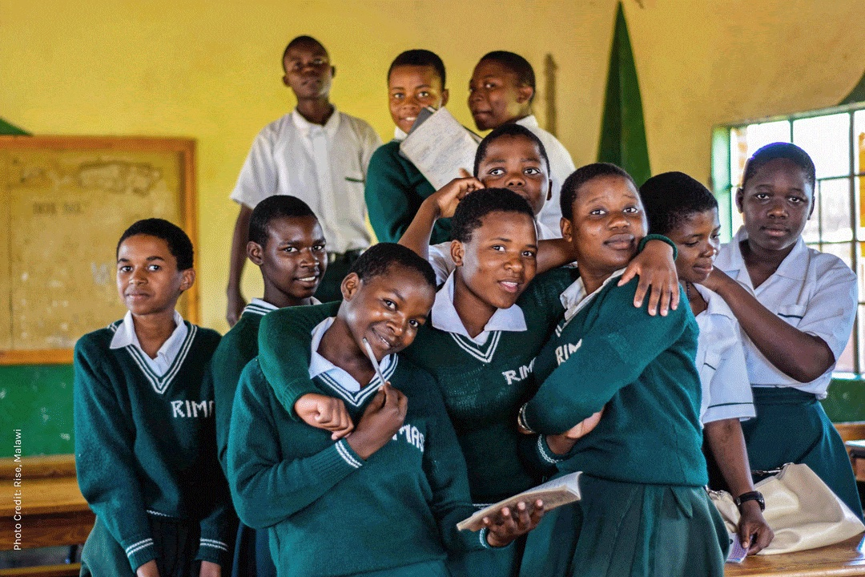
Lloyd Mphando is doing everything he can to help end the HIV pandemic in his community. His leadership journey started at just 12 years old, when he joined the nutrition support program and teen club at SLF partner Rights Institute for Social Empowerment (RISE) in Malawi.
“The RISE nutritional support program made a huge difference for my life and family,” says Lloyd. “Like me, there are so many children living with HIV who need this kind of support.” The nutritious food packages RISE provided vastly improved his health and allowed him to stay on track with daily, life-saving antiretroviral treatment.
Now, at age 21, Lloyd gives back by sharing his talents, time, and communication skills as a peer educator for the same teen club that nurtured him, put him on a path to health, and connected him to mentors. At RISE, he counsels young people, providing them with HIV prevention tools and antiretroviral treatment support for teens who are living with HIV.
It's all part of his determination to give young people the same life-changing support that benefitted him. “RISE helped me to bounce back after I learned that I was HIV positive and helped me to be strong to make informed choices about my health.” He hopes that through supports like peer education, more young people will be empowered to become role models in their communities.
In Lloyd's case, the support from RISE has put him on a path to a hopeful future. Today, his dream is to become a health surveillance assistant for Malawi’s Ministry of Health, so that he can do even more to help people who are living with HIV. Your gift to the SLF ensures inspiring young leaders like Lloyd have the support they need to overcome the many inequities that continue to drive the AIDS pandemic.
Via SLF email 2022 10 06

