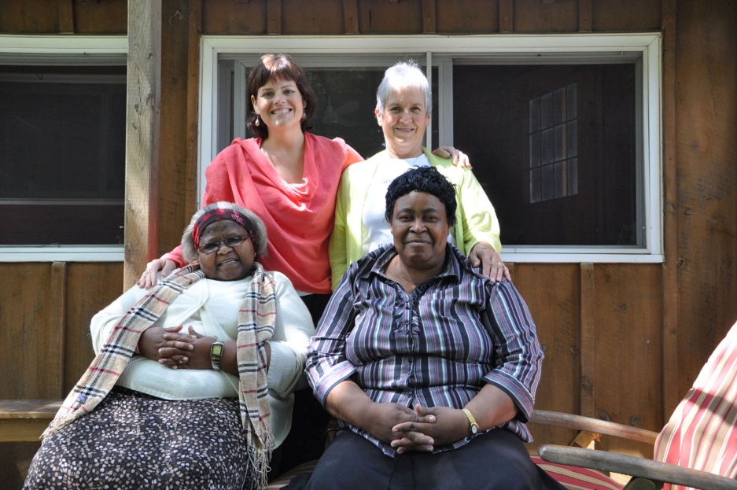

Mama Darlina and Siphiwe Hlope

Siphiwe is Founder and Director, Swaziland Positive Living (SWAPOL)

Siphiwe Hlophe was one of the first women in Swaziland to publicly declare her HIV positive status, and remains one of the country’s most prominent HIV/AIDS activists. She is the Director and a founding member of Swaziland Positive Living (SWAPOL), a national grassroots organization advocating for the rights and recognition of people affected by HIV and AIDS in her country. Seventeen of her twenty-four siblings have died of AIDS-related causes.

When Siphiwe found out she was HIV positive – during a series of routine tests to secure a scholarship to the University of Bradford in England – there was only one HIV/AIDS support group in Swaziland. No educated, married, working mother had ever publicly declared her status. AIDS was ravaging the country, and Siphiwe had already lost a sister to the disease.

In 2001, she and four other HIV positive women started SWAPOL. Today, the organization includes more than 4,500 people living with HIV and AIDS (PLWHAs) in 46 communities around Swaziland. SWAPOL works to fight stigma, care for AIDS orphans, look after the sick in their homes, educate people about HIV/AIDS, provide access to HIV counseling and testing, start small businesses, cultivate community gardens, and advocate for HIV treatment and support.

Siphiwe has served on the National Emergency Response Committee on HIV/AIDS, the Swazi government body coordinating prevention and care projects. She has been the Chairperson of the International Community of Women Living with HIV/AIDS in Swaziland, and a member of the UN Secretary General’s Task Force on Women, Girls and HIV/AIDS in Southern Africa. Siphiwe was the recipient of the 2006 African Women’s Development Fund’s Stephen Lewis Fighting Spirit Award and the 2007 Index on Censorship’s Freedom of Expression award, and she is featured in Stephanie Nolen’s book 28: Stories of AIDS in Africa.

In May 2010, Siphiwe organized the first-ever international African Grandmothers’ Gathering, in partnership with the Stephen Lewis Foundation. The Gathering brought together nearly 500 African grandmothers from 12 countries who joined together to share their experience of leading households devastated by AIDS and hammer out a common agenda for action and support.

