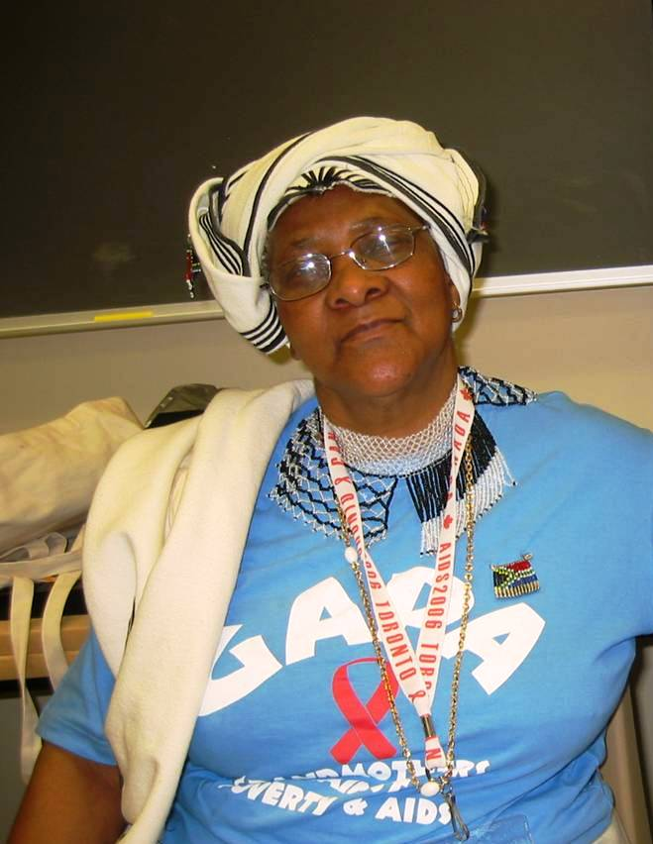
Alicia Mdaka
Grandmothers Against Poverty and AIDS, South Africa
Anne Philpot and Theresa Randles both attended the 2006 Grandmothers Gathering in Toronto, the first ever of its kind. 200 Canadian women joined 100 grandmothers and others from Africa, for a weekend that was the most spectacular gathering either had ever attended. In one of the workshops Anne attended, Alicia Mdaka spoke about her personal story. She was soft spoken, deeply touching and relayed her family's story.
When Alicia's first child died of AIDS Alicia was heartbroken and so devastated she didn't know how to go on - but she did. When her second child died of AIDS she said she didn't want to live any longer. But then she realized that she now had her grandchildren to raise. Soon she started to talk to other women and found that she wasn't the only mother who had lost children and now cared for grandchildren. They formed a group and found items to make crafts - they didn't just gather to make crafts but more importantly, she said that 'when women sit and work together they TALK'. They shared their stories, burdens and worries and began to help each other.
She summed up her story by saying, "and then together, we became strong, like grandmothers of STEEL". Alicia Mdaka is a member of GAPA in South Africa - Grandmothers Against Poverty and AIDS. When Anne and Theresa returned to Hamilton to start a grandmothers group, Anne remembered Alicia's story and suggested adopting the name Grandmothers of Steel, honouring the strength of African grandmothers and Hamilton's description as Steeltown.

